BLINKIT DATA ANALYSIS
- See all the data imported:
SELECT * FROM blinkit_data
- DATA CLEANING:
Cleaning the Item_Fat_Content field ensures data consistency and accuracy in analysis. The presence of multiple variations of the same category (e.g., LF, low fat vs. Low Fat) can cause issues in reporting, aggregations, and filtering. By standardizing these values, we improve data quality, making it easier to generate insights and maintain uniformity in our datasets.
UPDATE blinkit_data
SET Item_Fat_Content =
CASE
WHEN Item_Fat_Content IN ('LF', 'low fat') THEN 'Low Fat'
WHEN Item_Fat_Content = 'reg' THEN 'Regular'
ELSE Item_Fat_Content
END;

After executing this query check the data has been cleaned or not using below quer
SELECT DISTINCT Item_Fat_Content FROM blinkit_data;
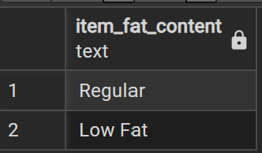

A. KPI’s
1. TOTAL SALES:
SELECT CAST(SUM(Total_Sales) / 1000000.0 AS DECIMAL(10,2)) AS Total_Sales_Million
FROM blinkit_data;
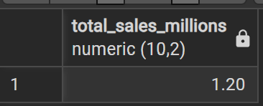

2. AVERAGE SALES
SELECT ROUND(AVG(sales),2) AS avg_sales
FROM blinkit_data;
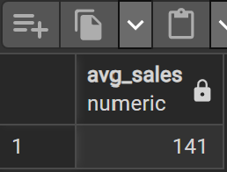

3. NO OF ITEMS
SELECT COUNT(item_identifires) AS no_of_items
FROM blinkit_data;
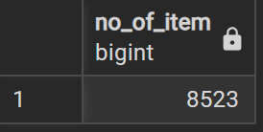
4. AVG RATING
select ROUND(avg(rating):: numeric , 1) as avg_rating
from blinkit_data
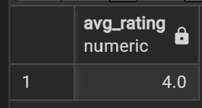
B. Total Sales by Fat Content:
SELECT Item_Fat_Content, CAST(SUM(Total_Sales) AS DECIMAL(10,2)) AS Total_Sales
FROM blinkit_data
GROUP BY Item_Fat_Content
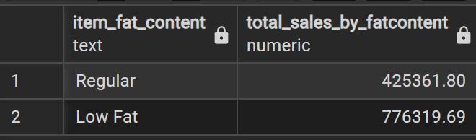
C. Total Sales by Item Type
SELECT Item_Type, CAST(SUM(Total_Sales) AS DECIMAL(10,2)) AS Total_Sales
FROM blinkit_data
GROUP BY Item_Type
ORDER BY Total_Sales DESC

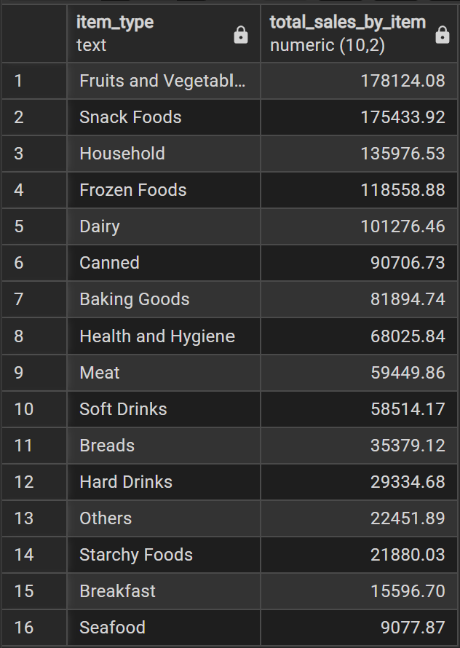

D. Fat Content by Outlet for Total Sales
SELECT
outlet_location_type,
round(SUM(CASE
WHEN item_fat_content = 'Low Fat'
THEN sales ELSE 0
END):: numeric ,2) AS low_fat,
round(SUM(CASE
WHEN item_fat_content = 'Regular'
THEN sales ELSE 0
END)::numeric, 2) AS regular
FROM blinkit_data
GROUP BY outlet_location_type
ORDER BY outlet_location_type;
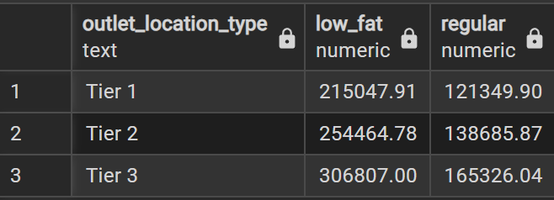

E. Total Sales by Outlet Establishment
select outlet_establishment_year, ROUND(sum(sales)::numeric,2) as total_sales
from blinkit_data
group by outlet_establishment_year
order by outlet_establishment_year;
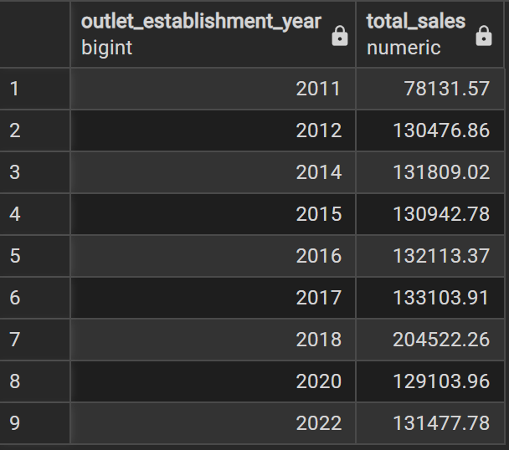
F. Percentage of Sales by Outlet Size
select outlet_size,
cast(sum(sales) as decimal(10,2)) as total_sales,
cast(sum(sales) * 100.0 /
(select sum(sales) from blinkit_data) as decimal(10,2)) as percentages_sales
from blinkit_data
group by outlet_size
order by total_sales DESC;
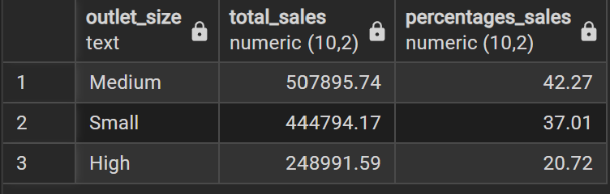
G. Sales by Outlet Location
select outlet_location_type,
ROUND(sum(sales):: numeric,2) as total_sales_as_location
from blinkit_data
group by outlet_location_type
order by total_sales_as_location DESC;
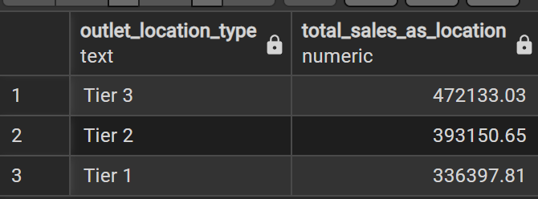
H. All Metrics by Outlet Type:
SELECT Outlet_Type,
CAST(SUM(sales) AS DECIMAL(10,2)) AS Total_Sales,
CAST(AVG(sales) AS DECIMAL(10,0)) AS Avg_Sales,
COUNT(*) AS No_Of_Items,
CAST(AVG(rating) AS DECIMAL(10,2)) AS Avg_Rating,
CAST(AVG(item_visibility) AS DECIMAL(10,2)) AS Item_Visibility
FROM blinkit_data
GROUP BY Outlet_Type
ORDER BY Total_Sales DESC

